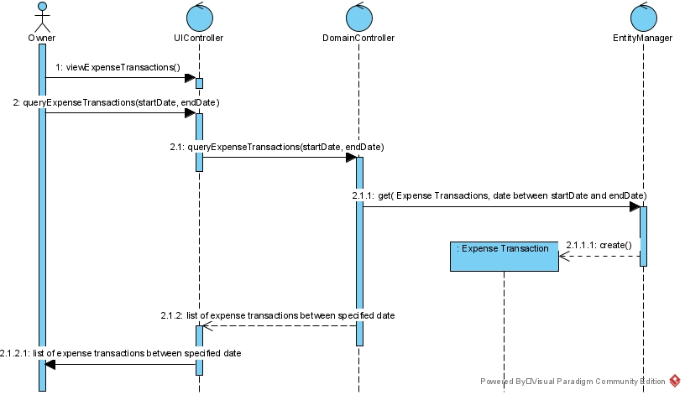 **Question 1 (worth 10 marks)**

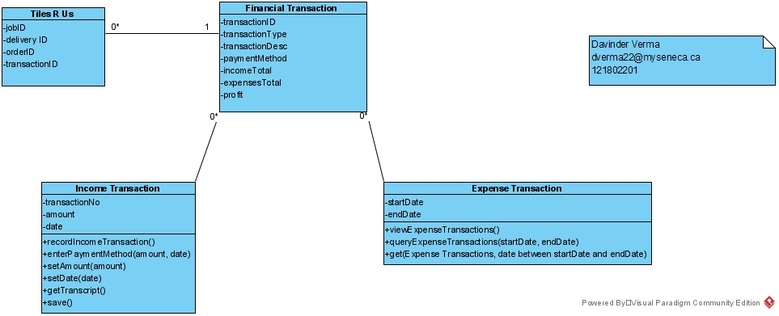Complete a **class diagram** to support what your team has learned so far about *Tiles R Us.*

**Question 2 (worth 20 marks)**

Complete **object level sequence** diagrams to support the above scenarios.

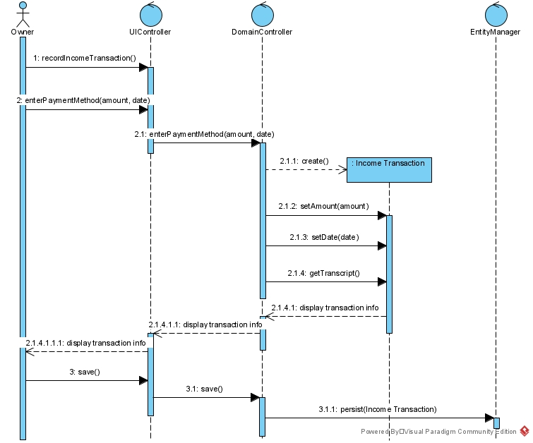

**Question 3 (worth 3 marks)**

Ally is considering recording the customer related to each sale. How will this change your class diagram? How will this change the scenarios and sequence diagrams? Please describe in English.

*For recording the all the customer transactions, I will make a new customer table which include all the information related to the purchase. Which will include info such as bill no, customer no, amount, and date. The income transaction will also change. I will change the attribute for the customer no which differentiates all the customers from each other and will be very easy to track as every customer will have unique number. There will be change in the scenario, for example ally will take the customer number for each customer transaction for her record. The sequence diagram will also change, I will add the customer number as new create function and in income transactions, she will add the customer information.*

**Question 4 (worth 3 marks)**

One of Ally’s favourite suppliers offers points on purchases. Ally like to include these points when summarizing her transactions. She would like to record when she uses points to buy products from these suppliers. From the government’s standpoint, these sales are HST exempt. How would you change the model that you created to support this change in requirements?

*For that I will make a new points class. It will have the record of all the points she added over time. During the checkout at the expense transaction, I will add the points card for redeem option. In the expense sequence diagram, I will add a new function will add ask for the number of points to redeemed. A new function will deduct the points from the total. So, the total after the points will be calculated for the tax.*

**Question 5 (worth 3 marks)**

Some goods and services are HST exempt? What are they? Would there be any benefits to Ally’s tile business?

*Yes, there are tax exempt items. They are long term residential rents, health and dental care, educational services, day-care services, music lessons, legal aid services, and financial services. So for these tax is not deducted. Insurance will be a good example for ally’s business. She won’t have to pay taxes for the insurance she has for her employees.*

**Question 6 (worth 3 marks)**

Ally is a small business owner. Some of her clients have asked if they pay cash, can they avoid paying tax? Is this a good idea for Ally? What about her clients?

*No, nothing is tax exempted if not mentioned by government. So should allow the customers to pay by cash and some poor or uneducated people do not have bank accounts. So, if she doesn’t allow cash she can lose many potential customers. She should allow the cash but should keep good track of all the cash and for the billing, the process should be same as just the payment method is changed.*

**Question 7 (worth 3 marks)**

*Tiles R Us* project is documenting the business’s requirements for a new system. We’ve looked at Agile and Waterfall (Predictive) Project Management methodologies. You are a team of 3 analysts and a Project Manager. If you were the Project Manager, what Project Management Methodology would you use for this project? And why?

*I would like to use the agile project management methodology as it is based on lots and lots of collaboration. So, the bigger the team, more people with different minds and with lots of amazing ideas. So, the team will never be out of good ideas. We will also be much more effective as all the people will have their particular set of work to do and more work will be done in same amount of time because of more people working on the project. This methodology makes us concentrate on every minute details of the project so that there is much less room for errors and of course, the whole project will be tested thoroughly before deployment.*

***References: -***

"Agile project management: 12 key principles, 4 big hurdles ...." <https://www.cio.com/article/3156998/agile-project-management-a-beginners-guide.html>.

"TaxTips.ca - What goods and services are exempt, taxable ...." <https://www.taxtips.ca/gst/whatistaxable.htm>.